

If you have any safeguarding concerns:
URGENT CONCERN  about a child, young person or vulnerable adult in immediate danger |  |  |  |  |  |  | CONCERN  about a child, young person  or vulnerable adult in need or at risk of harm |  |  |  |  |  |  | CONCERN  about anyone or anything that may put someone else or you at risk of harm
refer  directly |  |  |  | and |  |  | Discuss concerns with:  Safeguarding Leads:  Jill Mumford  Tel: TBC  Email: safeguarding@nmbc.org.uk  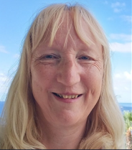  Huw Daniel  Tel: 07720 636096  Email: safeguarding@nmbc.org.uk  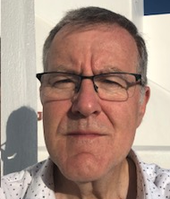  or Pastoral Team Leader:  Rev. Simon Bramwell  Tel: 0208 942 6912  or Safeguarding Lead at the LBA  (London Baptist Association):  Rachel Sawby  Tel: 07512 196646 |  |  |  |  |  |  | General Advice:  - Remember, your role is NOT to investigate  - Don’t promise confidentiality (in the case of a child)  - Always put the welfare of the child, young person or vulnerable adult first when deciding what to do  - Listen carefully, take what is said seriously, reassure them and remain calm  - Make a clear record of what you are concerned about and what you have seen or heard; include date and time you made the record  - Share the information you have with one of the Safeguarding Leads.
In an Emergency:

Police or Ambulance:
Tel: 999

Police non-emergency:
Tel: 101

Social Services L.A.D.O.
(Local Authority Designated Officer):
Tel: 020 8547 5008

020 8547 5005
(for adults)

020 8770 5000
(out-of-office hours)

Child & Vulnerable Adult Advocate:

NMBC has an independent person, not part of any ongoing safeguarding process, with whom a child, or vulnerable adult can talk.

Email for further information:
advocate@nmbc.org.uk

